Required Practical Activity:
Density 3

Note:
This resource is designed as a review of the required practical activity, covering all possible skills that could be developed through the investigation. This resource can be adapted to suit the needs of your class, depending on which skills your class need support with.

In this investigation we will use measurements of volume and mass to determine the density of a liquid.

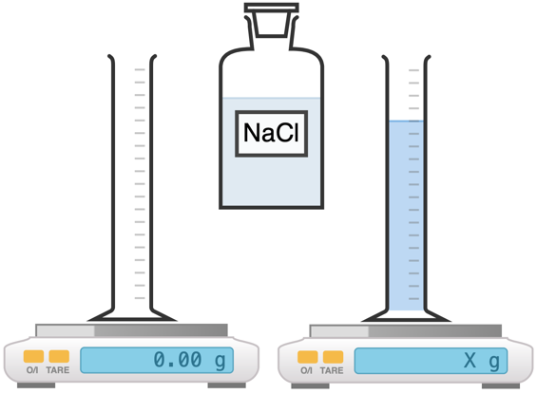

Method:

- Use the digital mass balance to measure the mass of an empty 100 ml measuring cylinder.
- Add approximately 100 ml of salt solution to the measuring cylinder and record the exact volume in your results table.
- Record the new mass of the measuring cylinder plus 100 ml of liquid and use this data to calculate the mass of the liquid.
- Calculate and then record the density of the liquid using the equation: density = mass/volume.
- Convert your density measurements into the standard units of kg/m³.
- Equipment:
- What measurements need to be taken in this investigation?
- What is the most suitable piece of apparatus to take measurements with? Why?
- Identify any hazards in this investigation.
- Why is it important that the balance is properly zeroed before weighing your object?

- What units will we use for measuring the volume of liquid?
- What is the relationship between 1 cm³ and 1 ml?
- What is the difference between weight and mass?
- What is the equation to calculate density?
- What will be our units for density if we measure mass in grams (g) and length in centimetres (cm)?
- What are the S.I. units for density?

- Results
Liquid | Volume (cm³) | Mass of empty measuring cylinder  (g) | Mass of measuring cylinder plus liquid  (g) | Mass of liquid  (g) | Density  (g/cm³) | Density  (kg/m³)
NaCl solution | 100 | 40.3 | 152.0 | 111.7 | 1.117 | 1117

- Explain why it is appropriate to round measurements taken with a ruler to the nearest millimetre.
- Is the density of the NaCl solution higher or lower than the density of pure water?

